CSc 148, Prof Mitchell - LittleLawDerivation_s18.doc: Little’s Law for queuing systems

The following derivation/proof is visual (graphical in format) and uses informal (not formal functional) analysis.
Notice that the proof does not make any special or ideal assumptions about {ia} or service duration distributions.
Little’s Law and can be applied in any stable server system in which, considering only waiting and service:
the mean waiting time, mean line length, and mean throughput (outflow) remain constant.
Also, the law can be applied to subsystems within a system as well.

Arrival and service events happen at integer time values (to simplify the diagrams).
<The diagrams are taken from previously cited reference textbook: Banks, Carson, et al., Ed#5>
Terms of the form term^ are a “statistical estimator” obtained from measurements on S as it operates.
For example, λ^ is the estimate of cj arrival rate and its expression in Step 7. below is expressed in terms
of observed quantities N and T.

1. Let T = max time value t in a run that simulates behavior of some system “S”

2. N = total number of customers ci who entered S

3. L(t) = number of ci in S at time t
W_{i} = total time spent in S by ci

4. Σ (1 <= i <= N) W_{i} = DefiniteIntegral (0 to T) L(t)dt (same integral as module P1) (1)
The left side of (1) represents total time in S by all ci, and geometrically is represented
by the SUM of all of the (height 1 and length W_{i}) labeled rectangles. (See Figure 6.8 below)
Note that some of the Wj tiles in Figure 6.8 occur more than one time. All such multiple occurrences
of the same Wj have been added in the sum in equation (1).
(Although confusing, this notation avoids double-indexing in the SUM)

The right side of (1) = area under the graph of (the number of ci in S) vs. time, from 0 to T

- L^ represents the estimate of the value of L at Steady State (SS)
T_{i} = subset of time T during which L(t) = i;

In Figure 6.6: The average value of i, or abbreviating this to avg (i) =
(1/T) * Σ (0 <= i <= ∞) (iT_{i})
Similar to Step 4, the multiple times that Ti occur in Figure 6.6 are each added into the Σ.

{Another way to think of the above expression is as a time-weighted average of i because
(Ti/T) is the fraction of T when there are i of the cj in S}
In Figure 6.6, for interval [0,20], 0*(3/20) + 1*(12/20) + 2*(4/20) + 3*(1/20) = 23/20 = 1.15 =avg(i)

By (1), L^ = (1/T) * DefiniteIntegral (0 to T) L(t)dt (2)
because, geometrically, Σ W_{i} (see Fig. 6.8) = left-side of Step 4 =
same area as Σ iT_{i}

- w^ is the estimate of SS residence time in S, per ci.
Then, w^ = (1 / N) * Σ (1 <= i <= N) W_{i} (by averaging over all ci) (5)

- λ^, the estimator of SS value of λ is N/T (X.1)

- Combining all above equations, we get a string of equalities, leading to the result:

By (2), L^ = (1 / T) * DefiniteIntegral (0 to T) L(t)dt, which
by (1) = (1/T) * Σ (1 <= i <= N) W_{i} , which
by (5) = (1/T) * N * w^ = (N/T) * w^, which
by (x.1) = λ^w^ (X.2)

In SS, each term z^ → z, that is, each statistic converges to its steady state value, so (X.2) becomes:
Little’s Law: L = λ w

Notes: In Figure 6.8, the indexes j for Wj displays the identity of waiting cj, for Wj at height >=2
Example: In time interval [7,8], c3 and c4 are both waiting.

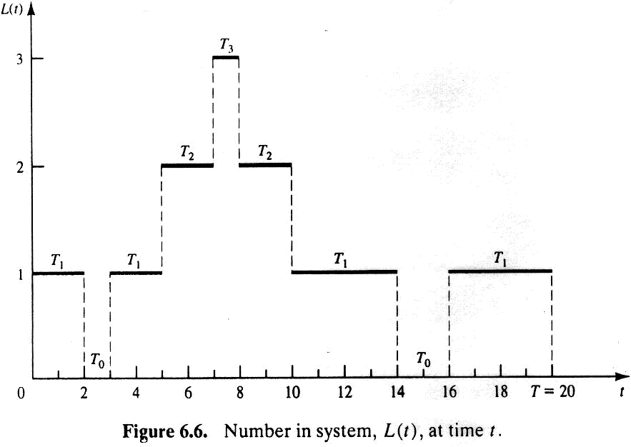
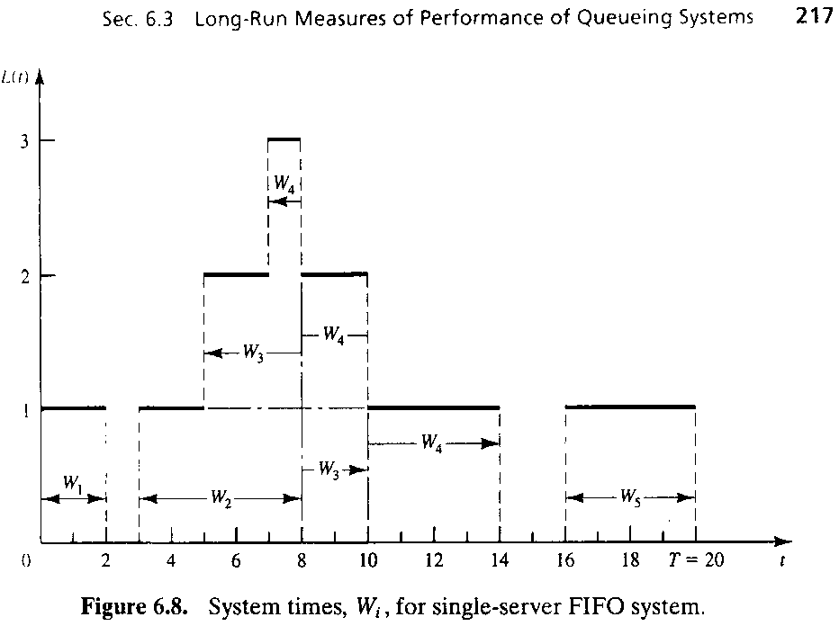

Each rectangle labeled Wj is unit-height, variable width. Ex: c4 had total residence time = (1+2+4) t.u. = 7 t.u.

